[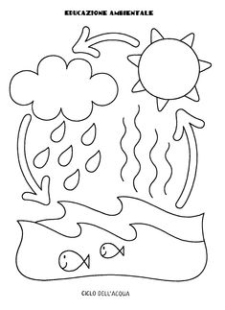](https://pl.pinterest.com/pin/16607092364044610/)